In this issue:
- What is the Architectural Committee and why am I receiving this newsletter?
- Election of Position 3 Architectural Committee Member.
- New Temporary Position 1 Architectural Committee Member
- Proposed annual reserve fee reinstatement and increase in fees.

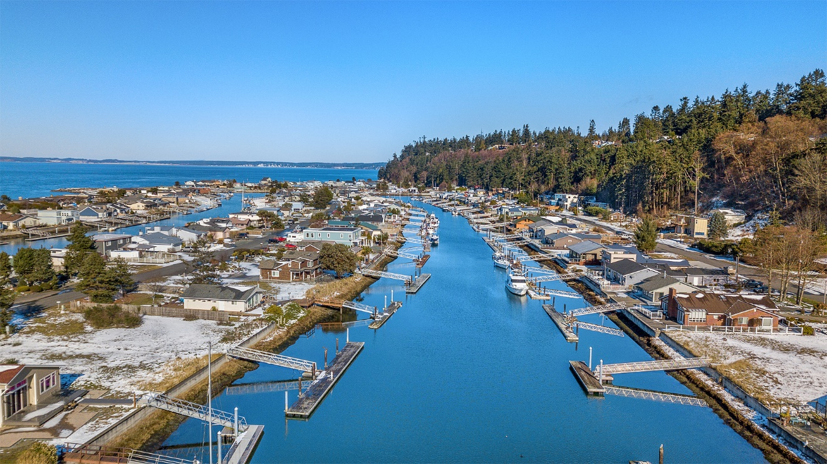
Photo from Denise Fjortoft
What is the Architectural Committee and why am I receiving this newsletter?
You are receiving this newsletter to explain new important changes that are being proposed that will affect you as a property owner and to explain the role of the Architectural Committee in effecting these changes.
You may or may not understand that as a property owner in Division 2-3-4, you are not only a member of the Lagoon Point Community Association but you are also a member of another homeowner’s association known as the Division 2-3-4 “Architectural Committee”. The Committee is sometimes mistakenly understood as a committee of the Lagoon Point Community Association when in fact it is an independent entity with its own authority granted by the Division 2-3-4 Covenants. (see Div. 2-3-4 Covenants at lagoonpoint.com )
The Architectural Committee is responsible for the approval of residential construction projects, the enforcement of Covenants and the protection and maintenance of the Division 2-3-4 right of ways. Those right of ways include the private community beach access on Oceanside Drive and the private canals. The private canals also include the southern portion of the waterway adjacent to Lot C known as the LPCA community waterway.
All 167 property owners in Division 2-3-4 currently pay a $15 annual fee for the Architectural Committee Operating Fund. Of the 167 lots there are 145 waterway lots that also pay into the Waterway Reserve Fund for the purpose of dredging. The other 22 lots are exempt from Waterway Reserve Fund contributions because they are not located on the canals. These 22 lots are beach lots on the west side Oceanside Drive.
Division 2-3-4 Members will be affected by the proposed changes differently. The exempt lots are only subject to the Architectural Committee Operating Fund contributions. The canal lots are subject to Operating Fund and Waterway Reserve Fund contributions.
It is important to remember that these fees have nothing to do with the fees collected for the Lagoon Point Community Association. The Waterway Reserve Fund provides for dredging the north end of the private Division 2-3-4 waterway that does not belong to and is not the responsibility of the Lagoon Point Community Association Membership.
Election for Position 3 Architectural Committee Member:
Although the Architectural Committee is a separate autonomous entity, both the LPCA and the Architectural Committee have linked themselves to each other through the Bylaws and the Division 2-3-4 Covenants for the purposes of cooperating on issues of mutual interest. The Covenants state that the Architectural Committee will be governed by the Bylaws of the LPCA and that elections will be held at the same time and in the same manner. Position 3 currently held by Reed Dow would normally expire on December 31, 2019. Changes to the LPCA Bylaws require his term to expire on June 30, 2019. Reed Dow is willing to serve another term and will appear on the ballot to be mailed in March, 2019. Any Member wishing to run against Reed for this position should submit his/her name to the Architectural Committee prior to March 8, 2019 for inclusion on the ballot.
New Temporary Position 1 Architectural Committee Member:
Position 1 Architectural Committee Member Cliff Lenz has asked for a sabbatical from the Committee due to the passing of Lana, Cliff’s wife of 44 years. Cliff’s term will expire on June 30, 2020. Under the provisions of the Covenants, Christine Anderson was appointed by the Committee Members to fill Position 1 until Cliff is ready to resume his duties.
DIVISION 2-3-4 ANNUAL FEES FOR FISCAL YEAR 2019/2020
On February 20th the Members of the Architectural Committee met to review the Division 2-3-4 Operating Fund and the Division 2-3-4 Waterway Reserve Fund as required for the Fiscal Year 2019-2020 ballot. The following proposals were approved by the Committee to appear on the Division 2-3-4 ballot.
Division 2-3-4 Operating Fund:
This fund provides for the administrative expenses required for things like printing and mailing of ballots, bookkeeping and legal services. It funds services provided exclusively for the Division 2-3-4 Members and should not be confused with Lagoon Point Community Association expenses. By mutual agreement the LPCA does provide accounting, bookkeeping, mailing and printing along with tax preparation for the Architectural Committee and this fund is used to reimburse LPCA for those expenses. It will also be used to fund projects like updating and revising the Covenants and development of a Shoreline Master Plan.
Although the $15 per year fee for the Operating Fund has been sufficient for the above purposes, it is also necessary to have sufficient funds to enforce the Covenants should those Covenants be challenged. The Architectural Committee has been advised by legal counsel that the Operating Fund is insufficient for such purposes because in the event of a challenge, the Committee may be obligated to pursue enforcement.
The Operating Fund Fee has remained static for years and the Committee is proposing it be increased from $15 per year to $35 per year for the Fiscal Year 2019-2020. This will appear on the Fiscal Year 2019-2020 ballot. The current balance of the Operating Fund is $23,432.

Division 2-3-4 Waterway Reserve Fund:

In the spring of 2017 the previous Architectural Committee believed the Special Waterway Fund was large enough and recommended the Division 2-3-4 Members suspend the $105 per year contribution until the fund balance drops below $250,000. The Members voted to suspend contributions to the Special Waterway Fund.
In reviewing the Reserve Study projections, the next dredging will occur in 2025 and based on the actual 2013 dredging cost of $290,696, the 2025 dredging cost adjusted for inflation will be $414,463. The Waterway Fund will be inadequate, requiring a special assessment. The Division 2-3-4 Members will be required to pay a special assessment of $151,736 or $1,046 per Member. The bigger problem will be the next dredging period where we begin 2025 with a zero balance and 122 Members will have 12 years to raise $590,925 in inflation adjusted dollars for the 2037 dredging.
By reinstating the Waterway Fund fee to $210 this year and increasing by 3% each year thereafter, we should be fully funded for the next two dredging projects which should take us to the end of the 30-year reserve study, the Fiscal Year 2048-2049.

Some things to consider:
- As a Division 2-3-4 property owner you are responsible for two dredgings. As an LPCA Member you pay for dredging the Community Waterway known as Lot C. You are also required to pay for dredging the north end of the canals and the southern part of Lot C because these are Division 2-3-4 easements and not LPCA community property.
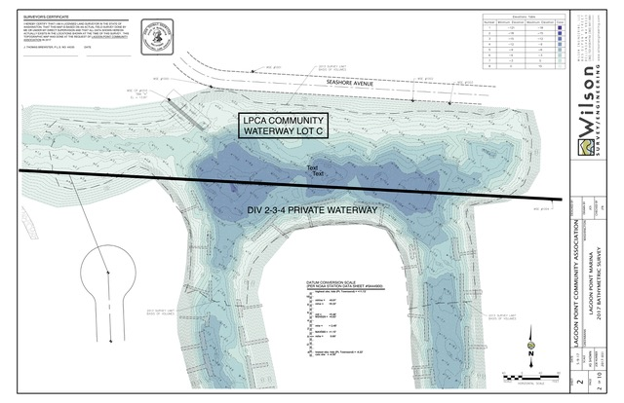
- Even though the proposal to increase the Division 2-3-4 Waterway Fund will fully fund dredging, it does not provide for dredging all of the private canals. Except for the north ends, the private canals have never been dredged but will likely need it eventually. Nothing is provided in this Reserve Study for dredging the private canals. Also, in the 31st year of the Reserve Study, another dredging will occur that will result in a revenue shortfall that may require raising the contribution rate at a later date.
3. Not reinstating the Division 2-3-4 Waterway Fund contributions will likely result in
special assessments for Division 2-3-4 owners.

Special assessments are the result of poor planning and present a financial hardship on many community members.
The Architectural Committee recommends reinstating the Annual Waterway fee and increasing it to $210 for Fiscal Year 2019/2020. According to Washington State Law the Fees are to be voted on each year by the Membership.
The last Dredging was done in 2013. The cost of the 2013 Dredging was:
LPCA paid $334,000
Division 2-3-4 paid $290,696
Total Cost of Dredging $624,696

The following is the rationale for the Fiscal Year 2019/2020 Annual Fees:
To forecast the cost of Division 2-3-4 dredging for the next 30 years the following process was used:
Year of Dredging | Number of Years between Dredging** | Inflation Rate per Year | Estimated Cost of Dredging
2013 Dredging Actual Costs* |  |  | $290,696
2025 Dredging | 12 | 3% | $414,463
2037 Dredging | 12 | 3% | $590,925
*Actual 2013 dredging costs were used for the cost basis.
**Dredging forecasts were provided by Wilson Engineering based on 2013 and 2017 Bathymetric surveys.

The following spreadsheet shows how much money Division 2-3-4 will have in reserve with a $210 annual fee contribution for Fiscal Year 2019/2020 and increasing 3% each year for inflation will have enough money to get through the 2025 and 2037 dredging.
DIVISION 2-3-4 RESERVE STUDY 2019 – THIRTY YEAR FORECAST
Fiscal Year | DIV 2-3-4 Waterway Reserves Fund | Annual Fees Adjusted for Inflation | Inflation Factor | Div 2-3-4 # of Lots | Adjusted for Inflation
2/24/2019 | Bank Balance |  |  |  | $50,014
2/24/2019 | Certificate of Deposit |  |  |  | $212,713
2019-20 | Waterway Reserve Fees | $210 |  | 145 | $30,450
2020-21 | Waterway Reserve Fees | $216 | 1.03 | 145 | $31,364
2021-22 | Waterway Reserve Fees | $223 | 1.03 | 145 | $32,304
2022-23 | Waterway Reserve Fees | $229 | 1.03 | 145 | $33,274
2023-24 | Waterway Reserve Fees | $236 | 1.03 | 145 | $34,272
2024-25 | Waterway Reserve Fees | $243 | 1.03 | 145 | $35,300
2025-26 | Waterway Reserve Fees | $251 | 1.03 | 145 | $36,359
2025 | Dredging Expense |  |  |  | ($414,463)
2025-26 | Reserve Balance |  |  |  | $81,586
2026-27 | Waterway Reserve Fees | $258 | 1.03 | 145 | $37,450
2027-28 | Waterway Reserve Fees | $266 | 1.03 | 145 | $38,573
2028-29 | Waterway Reserve Fees | $274 | 1.03 | 145 | $39,730
2029-30 | Waterway Reserve Fees | $282 | 1.03 | 145 | $40,922
2030-31 | Waterway Reserve Fees | $291 | 1.03 | 145 | $42,150
2031-32 | Waterway Reserve Fees | $299 | 1.03 | 145 | $43,414
2032-33 | Waterway Reserve Fees | $308 | 1.03 | 145 | $44,717
2033-34 | Waterway Reserve Fees | $318 | 1.03 | 145 | $46,058
2034-35 | Waterway Reserve Fees | $327 | 1.03 | 145 | $47,440
2035-36 | Waterway Reserve Fees | $337 | 1.03 | 145 | $48,863
2036-37 | Waterway Reserve Fees | $347 | 1.03 | 145 | $50,329
2037-38 | Waterway Reserve Fees | $358 | 1.03 | 145 | $51,839
2037 | Dredging Expense |  |  |  | ($590,925)
2037-38 | Reserve Balance |  |  |  | $22,147
2038-39 | Waterway Reserve Fees | $368 | 1.03 | 145 | $53,394
2039-40 | Waterway Reserve Fees | $379 | 1.03 | 145 | $54,996
2040-41 | Waterway Reserve Fees | $391 | 1.03 | 145 | $56,646
2041-42 | Waterway Reserve Fees | $402 | 1.03 | 145 | $58,345
2042-43 | Waterway Reserve Fees | $414 | 1.03 | 145 | $60,096
2043-44 | Waterway Reserve Fees | $427 | 1.03 | 145 | $61,899
2044-45 | Waterway Reserve Fees | $440 | 1.03 | 145 | $63,756
2045-46 | Waterway Reserve Fees | $453 | 1.03 | 145 | $65,668
2046-47 | Waterway Reserve Fees | $466 | 1.03 | 145 | $67,638
2047-48 | Waterway Reserve Fees | $480 | 1.03 | 145 | $69,667
2048-49 | Waterway Reserve Fees | $495 | 1.03 | 145 | $71,757
2048-49 | Reserve Balance |  |  |  | $706,010
Note: In the 31st year there is forecast for dredging and there is a projected shortfall.

Summary:
The Division 2-3-4 Members will receive a ballot mid-March 2019 to approve or disapprove $35 for the Operating Fund and $210 for the Waterway Reserve Fund for Fiscal Year 2019/2020. Your vote is due by April 12, 2019.
The following are the proposed Annual Fees for Fiscal Year 2019/2020 for Division 2-3-4 Lots:
Division 2 Non-Canal Lots Operating Fund $35
(22 Lots located on the westside of Oceanside Drive)

Division 2-3-4 Canal Lots -
(145 Lots located on the east & west canals) Operating Fund $35
Waterway Reserve Fund $210
Total $245

The $35 for all lots and $245 for canal lots will be in addition to the annual LPCA dues. The Architectural Committee realizes that this proposal will raise the canal lot owners combined LPCA and Division 2-3-4 dues to approximately $500 per year. This is a substantial increase. We believe this increase is necessary to maintain our marine infrastructure. LPCA dues still remain on the low end of the scale for similar communities. For example, Mariner’s Cove member dues are $750 per year.

If you have questions or concerns about either proposal, please contact Members of the Architectural Committee.

ARCHITECTURAL COMMITTEE contact information:

POSITION 1 (Acting) POSITION 2 POSITION 3
Chris Anderson Jim Norton Reed Dow
caanderson1978@gmail.com jknorton@whidbey.com reed@reeddow.com

END

